5th June, 2017
Software Requirements Specifications
Software Engineering Project

INVENTORY MANAGEMENT SYSTEM

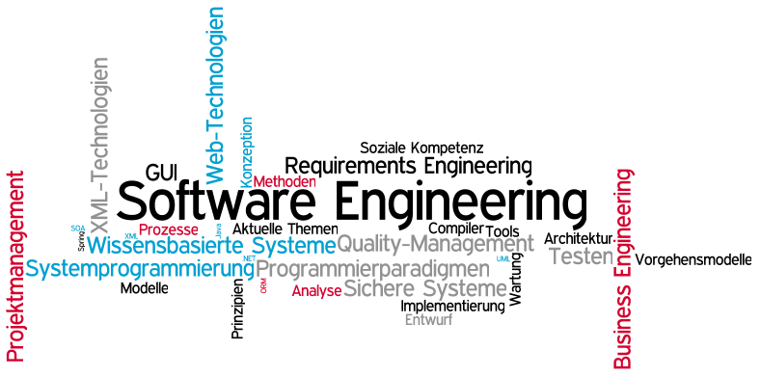

Instructor:

Sir Adeel Ahmed

Group Members:

Gresh kumar (1412168)

Table of Contents
1. Introduction 1
1.1 Purpose 1
1.2 Scope 1
1.3 Definitions, Acronyms, and Abbreviations 2
1.4 References 2
2. General Description 2
2.1 Product Perspective 2
2.2 Product Functions 3
2.3 User Characteristics 3
2.4 General Constraints 3
2.5 Assumptions and Dependencies 3
3. Specific Requirements 4
3.1 External Interface Requirements 4
3.1.1 User Interfaces 4
3.1.2 Hardware Interfaces 5
3.1.3 Software Interfaces 5
3.1.4 Communications Interfaces 5
3.2 Functional Requirements 5
3.3 Use Cases 6
3.3.1 Use Case #1 7
3.3.2 Use Case #2 7
3.3.3 Use Case #3 8
3.3.4 Use Case #4 8
3.3.5 Use Case #5 9
3.4 Design Constraints 9
3.5 Logical Database Requirements 9
3.6 ERD 10
4. Sequence Diagrams 11
4.1 Stock manager’s SD 11
4.2 Sales person’s SD 11
4.3 Owner’s SD 13
5. Collaboration Diagrams 14

1. Introduction

This article is intended to offer extension some assistance with Inventory Management System (IMS) needs of a venture and discover a technique that addresses the issues of the task, and all gatherings included, without including undue managerial or specialized overhead, and that is (ideally) effective, easy to use, and secure.

1.1 Purpose
The objective of this document is to describe the requirements of Inventory Management System. The target audience includes all the stakeholders involved in using this Management System who generally are Sales Person, Stock Person and Owner. It will give detailed description about the record of sale and purchase of Stock. Furthermore, the document will help to explain the features and interface of the system and a clear idea about the working of the system and the constraints under which the system will work.

This archive is critical for both clients and temporary worker as far as the business point of view. Software Developers should take this record as the premise of the prerequisites of this venture. Everything written in this record is an obligatory prerequisite of this venture. They ought to likewise consider further corrections made to this record for development and better comprehension of the prerequisites. Aside from that, any verbal or composed articulation is not viewed as legitimate until and unless it is said in this record.

1.2 Scope
The proposed software product is Inventory Management System (IMS) which is Stock Sal-Purchase Management System, offering services to the Business persons for handling the Sales in a feasible manner. The major component would be to offer a service that will provide feasible way to manage the stock through a proper computerized system. It will be designed to maximize the use of resources and time, by providing tools to scan item ID’s and generate bills, update Stock records, and see the availability status of the product etc. The application will be used to deliver services required for enhanced business.

The multiple view system which will be helpful in the filtration of records would replace the manual work. By maximizing the resources and views, system will meet the needs of both Sales Person, Stock Person and Owner as well. More specifically, this system is designed to allow three different people related to the business, do their job by keeping the records synchronized.

1.3 Definitions, Acronyms, and Abbreviations
IMS: Inventory Management System
Make Sale: Making New Sale of the Stock.
Desktop Application: an application that runs only on single Desktop.
Sign up: Owner create an account to provide authorized access to the respective person on the Desktop application.
User ID: a user identification to sign up.
Password: A bunch of characters that enable a user to be authorized to enter the Desktop Application.
SRS: Software Requirement Specification.

1.4 References
No Formal References have been taken for the document.

2. General Description
The Product is an Inventory Management System. It would mainly require two users among three to use the system frequently. The changes made by the Owner, will affect the access of the rest of the users to the system. For example, a limit provided by the owner on the stock would restrict the sales person to sale the stock in a defined limit.

2.1 Product Perspective
The perspective of this product is to allow easy and feasible way to manage the stock through a proper computerized system by the respective persons appointed to use the application. This application will allow the sales person to make new sale of the stock, stock person to maintain the purchasing of stock and the Owner to monitor the entire records. It will help business persons to keep track of the entire sales and purchase of stock, view the investments and the daily, monthly, weekly as well as yearly records.

2.2 Product Functions
The Software would be used to manage the sale of a firm. It would be providing the functionalities to keep track of the stock sale, and the stock purchase records as well. It also maintains the daily, monthly, monthly as well as yearly record of the sale and purchase of the stock. This would generate a bill for each and every sale. The software will keep track of the availability and unavailability status as well as the quantity status of the particular item.

2.3 User Characteristics
The Inventory Management System (IMS) has three active users that are Sales Person, Stock Person and Owner. There would be interaction between the records of Sales person and stock person as well as the Owner so as to keep track of the information, required for the records. The owner can access the entire system directly at any time and can edit anything.

2.4 General Constraints
When it comes to usability of the application, if somehow any person wants to access the data stored in the software, from any place, then this would generate some issues, since we are working on a desktop application, so it would not be feasible for a user to access the software or it’s data from any place other than the PC itself on which the application is installed. These usability constrains will be faced by the user. Each User would be provided a respective access to the application, only the owner would be having the access to look on the records of both sale and purchase of record. Therefore, Developer would not be able to provide same aces to all of the users.

2.5 Assumptions and Dependencies
The Product is Dependent upon Windows Operating System. It would not be possible to make it run on a Macintosh or Linux Operating System. Since it is a Desktop application, so the usability as well as access would be, just to that computer only. It is not possible to access the data from somewhere else than that particular PC. If such situation appears then the only alternate would be to access the application on windows and on that particular PC.

3. Specific Requirements
This will be the largest and most important section of the SRS. The customer requirements will be embodied within Section 2, but this section will give the D-requirements that are used to guide the project’s software design, implementation, and testing.

Each requirement in this section should be:
- Correct
- Traceable (both forward and backward to prior/future artifacts)
- Unambiguous
- Verifiable (i.e., testable)
- Prioritized (with respect to importance and/or stability)
- Complete
- Consistent
- Uniquely identifiable (usually via numbering like 3.4.5.6)

Attention should be paid to the carefully organize the requirements presented in this section so that they may easily accessed and understood. Furthermore, this SRS is not the software design document, therefore one should avoid the tendency to over-constrain (and therefore design) the software project within this SRS.

3.1 External Interface Requirements

3.1.1 User Interfaces
The Sale Person, Stock Person and the Owner would be having their different access and different views.

Each User will be recognized by its Login verification, and then his/her respective view would appear.

Each user will have different options with respect to their access to the application.
Sales Person will have its own options to Make a new sale, generate sale bills for the customer, view the price of the product etc.
Likewise, there will be different options available on the Stock person’s view, like purchase stock, update stock’s availability status.
Similarly, the Owner will be having and a different view access to the application such as to view the entire records etc.

There will be multiple options for the owner to view the records in different possible ways and filter them as per his/her own wish.

The rest of the Users will also be provided to see different status of the amounts, purchases, sales and the product availability.

3.1.2 Hardware Interfaces
Since, it’s a Desktop application so there is a designated hardware. It has any direct hardware interface. However, the connection of hardware and data base server is managed by the operating system.

3.1.3 Software Interfaces
The Desktop Application communicates with the database in order to give access to the Sales Person to make new sales feasibly, the Stock Person to deal with updating of stock, and the Owner to access and filter the records.

3.1.4 Communications Interfaces
The communication between the parts of system is not needed.

3.2 Functional Requirements
"A functional requirement is a capacity that a framework or part must have the capacity to perform."
Useful functional requirements determine particular conduct or capacities, for instance.
Characteristically Some functional requirement:
- Transaction corrections, adjustments, cancellations
- Administrative functions
- Authentication
- Audit Tracking
- Ropes the footage of Actual Cost by Product.
- Supports the recording of FIFO Cost by Product
- Supports Planning Identifier for Make Only, Buy Only, or a Combined Value for On-Going Make/Buy Analysis
- Supports Identification of Multiple Vendors and Associated Information per Product.

3.3 Use Cases
USE CASE DIGRAM

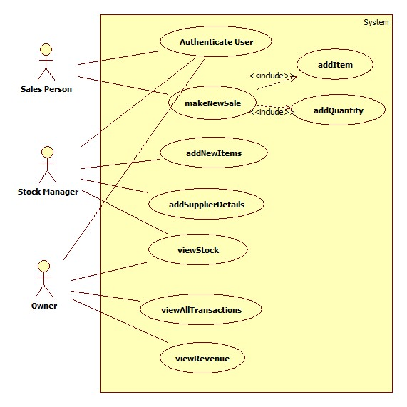

3.3.1 Use Case #1
Title: User Login
Primary Actor: Owner / Sales Person / Stock Person
Scenario: The user of the application must log in to view the respective details, like the Sales person must login in to fulfil his duties, stock person will also login to fulfil his duties and similarly the Owner to view the transaction history and provide authentication.
Secondary Actor: Application
Pre-Conditions:
- He/she must have an ID password to get access to the application.
Basic Flow:
- He/she open his/her panel.
- Enter his/her username and password.
- The database will authenticate that user.
- Now he/she will be able to do his/her work.
Alternative Flow:
- In case, if the user enters invalid username or password, he/she has t re-enter that.
Post-Conditions:
- The user will be login to the system.

3.3.2 Use Case #2
Title: Make New Sale
Primary Actor: Sales Person
Scenario: The Sales Person will add the items to the application, and the quantity of the stock
Secondary Actor: Application
Pre-Conditions:
- Sale Person must be Login to the application.
- S/he must assure that stock is not empty.
Basic flow:
- The Transaction ID will automatically be assigned to that sale.
- S/he will enter the product ID, name, quantity, and unit price.
- The system will add products to the cart and make total bill.
Alternative flow:
- In case, if user enters the product that is not available into the stock.
The system will signal user that product is not available.
- If user enters the quantity that is not sufficient, the system will signal user that quantity is large.
Post-Conditions:
- System must calculate the total cost up till the products are added.
- System Must Generate Bills of the Sale.

3.3.3 Use Case #3
Title: Add New Item
Primary Actor: Stock Person
Scenario: The Stock Person will add the information of the new items of the purchased stock to the application, and the quantity of the stock, and the relevant information of the new stock
Secondary Actor: Application
Pre-Conditions:
- Stock Person must be Login to the application.
Basic flow:
- The Transaction ID will automatically be assigned to that purchase.
- S/he will enter the supplier ID, product ID, name, quantity, and unit price.
- The system will add products to the Stock and make total of the net costs.
Alternative flow:
- In case, if user enters the supplier ID that is not available into Suppliers list
The system will signal user that add the supplier first.
Post-Conditions:
- System must update the record of the expenditures.
- System must update the stock’s availability stats to the Sales person’s view.

3.3.4 Use Case #4
Title: Add Supplier’s Details
Primary Actor: Stock Person
Scenario: The Stock Person will add the information of the Suppliers of the purchased stock to the application, and the relevant information of the supplier.
Secondary Actor: Application
Pre-Conditions:
- Stock Person must be Login to the application.
- System must show the current all the suppliers of the particular stock.
Basic flow:
- The user will open the supplier record.
- The User will click the add supplier button into the supplier panel.
- S/he will enter the all supplier details and the supplier ID will automatically be assigned to that supplier.
Post-Conditions:
- System must update the stock purchase from the Last supplier.

3.3.5 Use Case #5
Title: View Transactions
Primary Actor: Owner
Scenario: The owner will see the all possible transaction done through the management system to the application, and then can filter these records as per his own wish by month, day, or year.
Secondary Actor: Application
Pre-Conditions:
- Owner must be Login to the application.
- System must show the keep the entire records of the transactions updated.
Basic flow:
- S/He will login to his/her panel.
- Will open the transaction panel of his/her choice.
Alternative Flow: None.
Post-Conditions:
System must update the record of the expenditures.
System must update the stock’s availability stats to the Owner view.

3.4 Design Constraints
The design constraint would be to link the application with a Local server, to support and enable the feature of having updated records for both the sales person and stock person, in order to maintain the records.

3.5 Logical Database Requirements
The Database will be surely used for the application to enable the feature of storage of data, synchronous updating of data, and the updating of records as well which would be visible to the owner. The other usage of database would be to keep the backup of the entire records and also to make the data appear for the different views of the application.

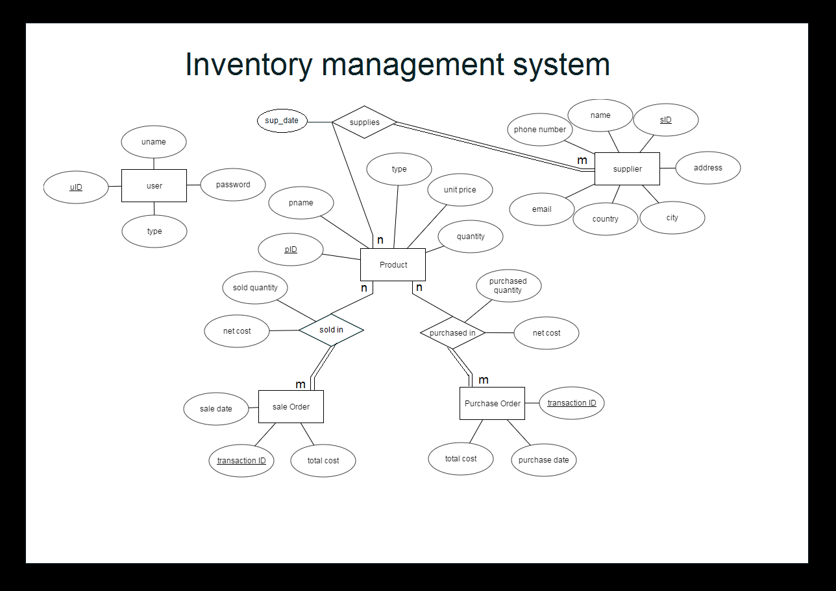
3.6 ERD

4. Sequence Diagrams

4.1 Stock manager’s SD
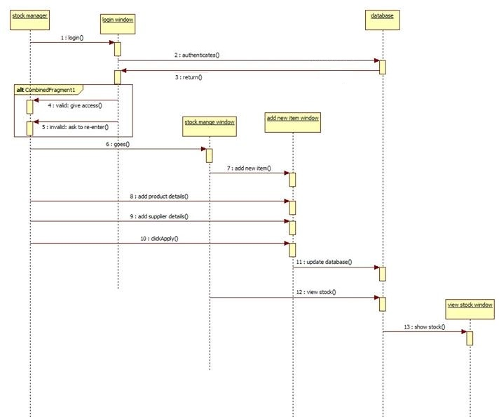

4.2 Sales person’s SD

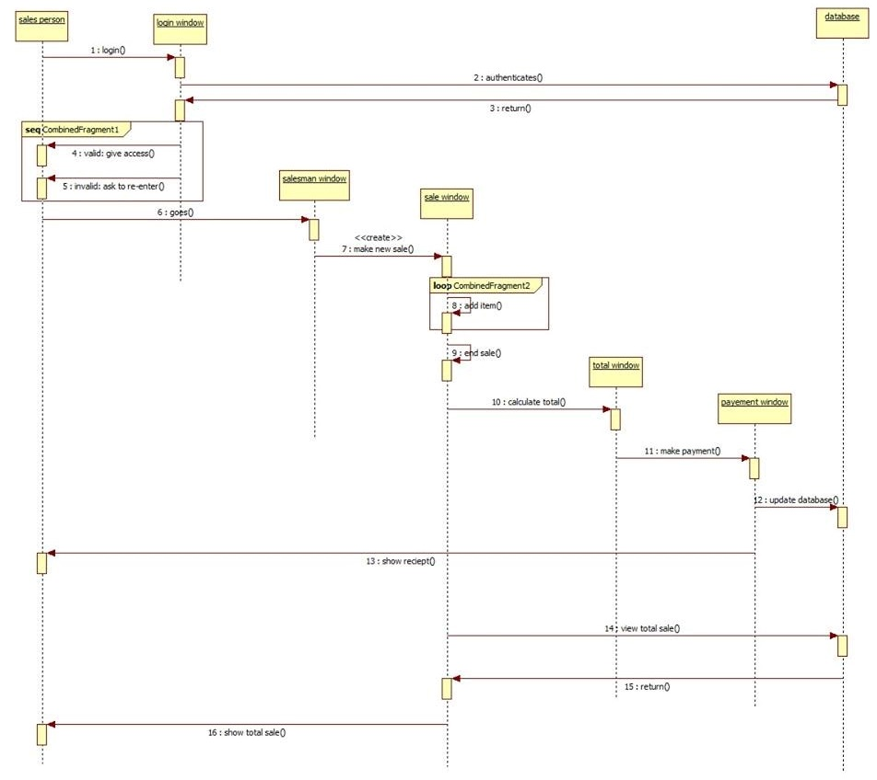

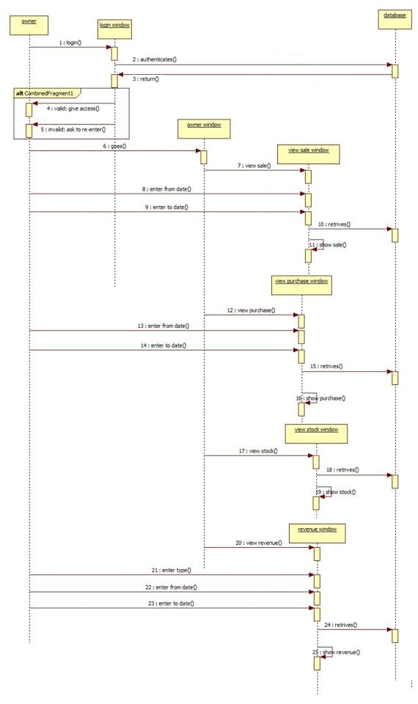
4.3 Owner’s SD

5. Collaboration Diagrams
